Pract:8

AIM

Designing of different network topologies using NS2.

THEORY

Network Simulator 2 (NS2)
NS2 is an open-source, discrete-event network simulator widely used in research and teaching. Its core is written in C++ and it uses OTcl (Object-oriented Tcl) as the front end, so a simulation is described by a Tcl script. When the script runs, NS2 produces two output files: a trace file (.tr) that records every packet event, and a NAM file (.nam) that the Network Animator (NAM) uses to visualise the simulation.

Network Topology
Network topology is the arrangement of nodes and links in a network. Topology affects cost, performance, fault tolerance and ease of expansion. The topologies simulated in this experiment are:
- Point-to-point: two nodes connected directly by a dedicated link.
- Bus: all nodes share a single communication medium. It is cheap and simple, but the shared medium causes collisions and a single cable fault can bring the network down. In NS2 it is modelled with a LAN object (make-lan).
- Star: every node connects to a central hub or switch. Adding nodes is easy and a failed node does not affect the others, but the hub is a single point of failure.
- Ring: each node connects to exactly two neighbours, forming a closed loop. Data travels around the ring, and one broken link can disrupt traffic unless the ring is bidirectional.
- Mesh: every node is connected to every other node. It offers high reliability and multiple paths, but needs n(n-1)/2 links, which makes it expensive.
- Tree: a hierarchy of nodes with a root and branching child nodes. It scales well and suits large networks, but failure of a parent node isolates its subtree.
- Hybrid: a combination of two or more of the above topologies.

Key NS2 Commands
Command | Purpose
new Simulator | Creates the simulator object
$ns node | Creates a network node
$ns duplex-link n1 n2 bw delay queue | Creates a two-way link between two nodes
$ns make-lan "nodes" bw delay LL Queue Mac | Creates a shared LAN (used for bus)
Agent/UDP, Agent/Null | Traffic source and receiving sink
Application/Traffic/CBR | Constant bit rate traffic generator
$ns at time "action" | Schedules an event
$ns run | Starts the simulation

Trace File Format
Each line of the trace file begins with an event symbol: + (enqueue), - (dequeue), r (receive) and d (drop), followed by the time, the from-node and to-node, packet type, size, flags, flow id, source and destination addresses, sequence number and packet id.

STEPWISE IMPLEMENTATION

Step 1: Install and verify NS2
sudo apt update
sudo apt install ns2 nam
ns # the % prompt should appear; type exit to quit

Step 2: Plan the script structure
Every NS2 script follows the same sequence: create the simulator, open the trace files, define the finish procedure, create nodes, create links (this defines the topology), attach agents and applications, schedule events, and run.

Step 3: Common header (used in every script)
set ns [new Simulator]

set nf [open out.nam w]
$ns namtrace-all $nf
set tf [open out.tr w]
$ns trace-all $tf

proc finish {} {
global ns nf tf
$ns flush-trace
close $nf
close $tf
exec nam out.nam &
exit 0
}

Step 4: Topology section and traffic
After the header, insert the topology code from Step 5, then add the traffic section below. Replace the receiving node ($n3 here) according to the topology.
set udp [new Agent/UDP]
$ns attach-agent $n0 $udp
set sink [new Agent/Null]
$ns attach-agent $n3 $sink
$ns connect $udp $sink

set cbr [new Application/Traffic/CBR]
$cbr set packetSize_ 500
$cbr set interval_ 0.01
$cbr attach-agent $udp

$ns at 0.5 "$cbr start"
$ns at 4.5 "$cbr stop"
$ns at 5.0 "finish"
$ns run

Step 5: Topology-specific code

5.1 Point-to-point
set n0 [$ns node]
set n1 [$ns node]
$ns duplex-link $n0 $n1 1Mb 10ms DropTail

5.2 Bus Topology (bus.tcl)
set n0 [$ns node]
set n1 [$ns node]
set n2 [$ns node]
set n3 [$ns node]

$ns make-lan "$n0 $n1 $n2 $n3" 10Mb 10ms LL Queue/DropTail Mac/802_3
Receiving node used in the traffic section: $n3.

5.3 Star Topology (star.tcl)
set n0 [$ns node] ;# central hub
for {set i 1} {$i <= 5} {incr i} {
set n$i [$ns node]
$ns duplex-link $n0 [set n$i] 1Mb 10ms DropTail
}
Receiving node used in the traffic section: $n3.

5.4 Ring Topology (ring.tcl)
for {set i 0} {$i < 6} {incr i} {
set n$i [$ns node]
}
for {set i 0} {$i < 6} {incr i} {
set j [expr ($i + 1) % 6]
$ns duplex-link [set n$i] [set n$j] 1Mb 10ms DropTail
}
Receiving node used in the traffic section: $n3.

5.5 Mesh Topology (mesh.tcl)
set N 5
for {set i 0} {$i < $N} {incr i} {
set n$i [$ns node]
}
for {set i 0} {$i < $N} {incr i} {
for {set j [expr $i + 1]} {$j < $N} {incr j} {
$ns duplex-link [set n$i] [set n$j] 1Mb 10ms DropTail
}
}
Receiving node used in the traffic section: $n3.

5.6 Tree Topology (tree.tcl)
for {set i 0} {$i < 7} {incr i} {
set n$i [$ns node]
}
$ns duplex-link $n0 $n1 2Mb 10ms DropTail
$ns duplex-link $n0 $n2 2Mb 10ms DropTail
$ns duplex-link $n1 $n3 1Mb 10ms DropTail
$ns duplex-link $n1 $n4 1Mb 10ms DropTail
$ns duplex-link $n2 $n5 1Mb 10ms DropTail
$ns duplex-link $n2 $n6 1Mb 10ms DropTail
Receiving node used in the traffic section: $n6.

Step 6: Optional NAM layout settings
$n0 color red
$n0 shape box
$ns color 1 Blue
$udp set class_ 1
$ns duplex-link-op $n0 $n1 orient right
$ns duplex-link-op $n0 $n1 queuePos 0.5

Step 7: Run the simulation
ns bus.tcl
ns star.tcl
ns ring.tcl
ns mesh.tcl
ns tree.tcl
NAM opens automatically at the end of the run. Click Play to watch packets travel through the topology.

Step 8: Analyse the trace file
grep "^r" out.tr | wc -l # packets received
grep "^d" out.tr | wc -l # packets dropped

OUTPUT
Running each script opens NAM, where the nodes and links appear as shown below. The diagrams are illustrative representations of the topology created by each script. Replace or supplement them with screenshots of your own NAM window if your lab requires it.

Bus Topology
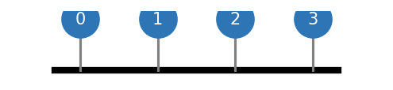
Fig 1: Bus Topology

Star Topology
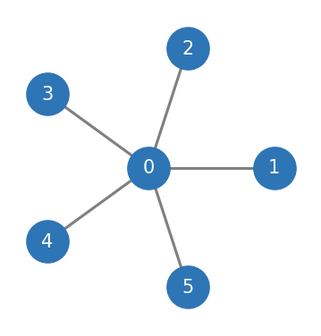
Fig 2: Star Topology

Ring Topology
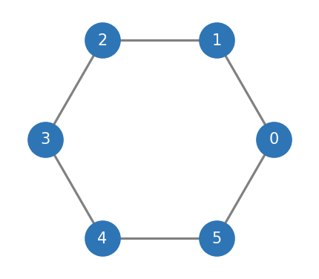
Fig 3: Ring Topology

Mesh Topology
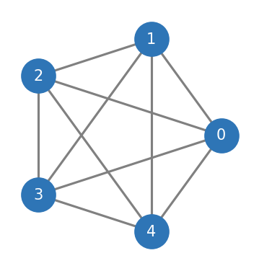
Fig 4: Mesh Topology

Tree Topology
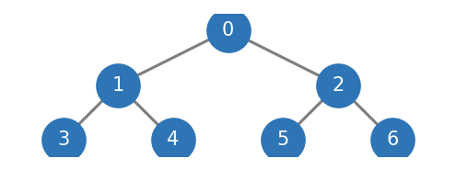
Fig 5: Tree Topology

Sample trace file output (out.tr)
+ 0.5 0 1 cbr 500 ------- 1 0.0 3.0 0 0
- 0.5 0 1 cbr 500 ------- 1 0.0 3.0 0 0
r 0.5124 0 1 cbr 500 ------- 1 0.0 3.0 0 0
+ 0.51 0 1 cbr 500 ------- 1 0.0 3.0 1 1

